**AI (ML DL) April15**

**Project**

**On**

AI Enabled Weed Recognition System

Using

Deep learning Algorithms

By Team 56

1)Sai Saritha

2)Vegesna Harshitha

3)Penumatsa Pushpa

4)Ashley Kispotta

**Table of Contents**

|  |  |  |  |  |  |
| --- | --- | --- | --- | --- | --- |
| **1** | |  | **INTRODUCTION** | |  |
|  | |  | 1.1 Overview | |  |
|  | |  | 1.2 Purpose | |  |
| **2** | |  | **LITERATURE SURVEY** | |  |
|  | |  | 2.1 Existing problem | | |
|  | |  | 2.2 Proposed solution | | |
| **3** | |  | **THEORITICAL ANALYSIS** | |  |
|  | |  | 3.1 Block diagram | |  |
|  | |  | 3.2 Hardware / Software designing | | |
|  | |  |  | | |
| **4** | |  | **FLOWCHART** | |  |
| **5** | |  | **RESULT** |  |  |
| **6** | |  | **ADVANTAGES & DISADVANTAGES** | | |
| **7** | |  | **APPLICATIONS** | |  |
| **8** | |  | **CONCLUSION** | |  |
| **9** | |  | **FUTURE SCOPE** | |  |
| **10** | |  | **BIBILOGRAPHY** | |  |
|  | |  | **APPENDIX** | |  |
|  |  | | 1. Source code | |  |
|  |  |  |  |  |  |

1. **Introduction**

* 1. **Overview:**

Weeds are undesirable plants that grow in agricultural crops, such as soybean crops, competing for elements such as sunlight and water, causing losses to crop yields. The objective of this work was to use Convolutional Neural Networks (CNNs) to perform weed detection in crop images and classify these weeds among grass and broadleaf, aiming to apply the specific herbicide to weed detected.With these photographs, an image database was created containing over fifteen thousand images of the soil, soybean, broadleaf and grass weeds. The Convolutional Neural Networks used in this work represent a Deep Learning architecture that has achieved remarkable success in image recognition. As a result, this work achieved above 98% accuracy using ConvNets in the detection of broadleaf and grass weeds in relation to soil and soybean, with an accuracy average between all images above 99%.

**1.2 Purpose:**

In recent years, the DL methods have become popular as they allow researchers to improve the weed recognition and are used for various engineering applications.

CNNs can be thought of automatic feature extractors from the vector. While if we use a algorithm with pixel vector I lose a lot of spatial interaction between pixels, a CNN effectively uses adjacent pixel information to effectively downsample the image first by convolution and then uses a prediction layer at the end.

The main reason behind CNN is feature engineering not required. Before CNN, we need to spend so much time on feature selection ( algorithm for features extraction). When we compare handcrafted features with CNN, CNN performance well and it gives better accuracy. It is covering local and global features. It also learns different features from image

**2) Literature Survey**

**2.1 Existing Problem**

Weed picking is one of the laborious job in fields. Weeds are the plants growing in a wrong place which compete with crop for water, light, nutrients and space, causing reduction in yield and effective use of machinery and can cause a disturbance in agriculture. Weeds can also host pests and diseases that can spread to cultivated crops.In olden days weed detection was done by employing some people, especially for that purpose. They will detect the weed by checking each and every place of the field. Then they will pluck them out manually using their hands..

**2.2 Proposed Solution**

We are Proposing a solution in the device is integrated with camera and there will be a live video streaming in that it will detect the weed in the crop by using image processing. This system will distinguish the crop and weed. Our system will use a Convolution neural network algorithm to extract the features from image and train them by using neural network.

**3)Theoretical Analysis**

**3.1 Block Diagram**

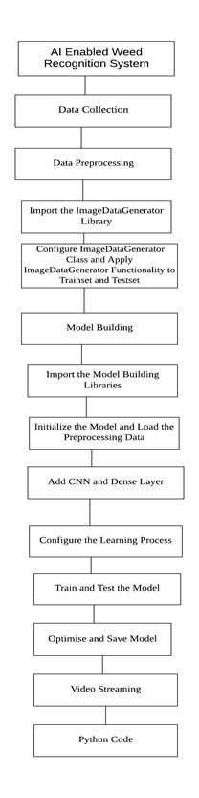

**3.2 Hardware / Software designing**

Python, Python for Data Collection, , Data Pre-processing Techniques, Deep Learning, video streaming usig CNN

**4)Flowchart:**

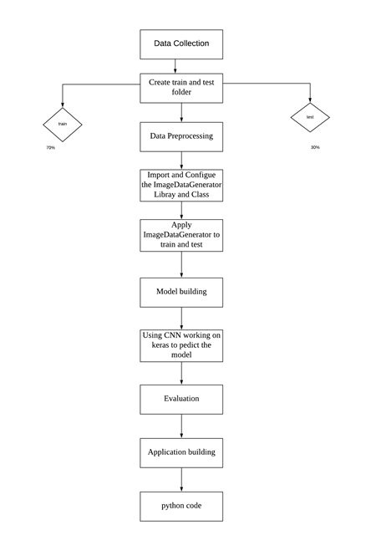

**5)Result**

By using Deep Learning algorithm for weed recognition. we have detected the weeds. . The objective of this work was to use Convolutional Neural Networks (CNNs) to perform weed detection in crop images and classify these weeds .we used the video streaming detecting the weeds .video streaming is the best choice for this problem .by this process 99% of the weed can be detected.

**6)Advantages and Disadvantages**

**Advantages:**

Reduce usage of chemicals

Improve crop quality

Improve soil quality

**Disadvantages :**

If there is a chance in failure of the camera in that situation it can be troublesome.

**7)Applications:**

* Can detect the weed using the inputs provided.
* Implementable on the website

**8)Conclusion**

In this study, Weed recognition was established by Video Stremming using CNN. A total of 15266 sample data collected and created a train and test folder.Data preprocessing was first calibrated ,and then model building takes place . next step is to the write a python code for the weed detection.Conclusions can be drawn as follows:

* Compare to all other Deep Learning Models ,CNN video streaming was best suitable for this data.
* By using this 99% of the weeds can be recognized.

**9)Future Scope**

We can integrate this model to robot where the robot recognise the weed and pick automatically

1. **Bibliography**

**References**:

1.ndújar, D., Weis, M., & Gerhards, R. (2012). for weed detection

2.Barker, J., Sarathy, S. and Tao, A., 2016. “ convolution Neural Network for weed detection

**Data repositories**

Kaggle.com

**Algorithms**

Thesmartbridgeteachable.com

1. **Appendix**

Source code:

from keras.models import Sequential

from keras.layers import Dense

from keras.layers import Conv2D

from keras.layers import MaxPooling2D

from keras.layers import Flatten

model=Sequential()

model.add(Conv2D(32,3,3,input_shape=(64,64,3),activation='relu'))

model.add(MaxPooling2D(pool_size=(2,2)))

model.add(Flatten())

#Add Output layer

model.add(Dense(init="uniform",activation=" sigmoid",output_dim=1))

#Compile the model

model.compile(loss="binary_ crossentropy",optimizer="adam",metrics=["accuracy"])

from keras. preprocessing.image import ImageDataGenerator

train_ datagen = ImageDataGenerator(rescale = 1./255,

shear_range = 0.2,

zoom_range = 0.2,

horizontal_flip = True)

x_train = train_datagen.flow_from_directory(r"C:\Users\saisaritha\Desktop\project\dataset\train_set",target_size = (64,64),batch_size = 32 , class_mode = "binary")  
x_test = test_datagen.flow_from_directory(r"C:\Users\saisaritha\Desktop\project\dataset\test_set",target_size = (64,64),batch_size = 32 , class_mode = "binary")

model.fit_generator(x_train,steps_per_epoch = 250,epochs=1,validation_data = x_test,validation_steps = 63)

prediction:

model.fit_generator(x_train,steps_per_epoch = 250,epochs=1,validation_data = x_test,validation_steps = 63)

model = load_model("cnn.h6")

img = image.load_img(r"C:\Users\saisaritha\Desktop\project\dog1.jpg",target_size= (64,64))

x = image.img_to_array(img)  
x = np.expand_dims(x,axis = 0)

x.shape

pred = model.predict_classes(x)

pred

MAIN CODE:

import cv2import numpy as np

from keras.preprocessing import image  
from keras.models import load_model

model=load_model('weed.h5')  
video=cv2.VideoCapture(0)  
name=["broadleaf","grass","soil","soyabean"]while(1):  
 sucess,frame=video.read()  
 cv2.imwrite("image.tif",frame)  
 img=image.load_img("image.tif",target_size=(64,64))  
 x=image.img_to_array(img)  
 x=np.expand_dims(x,axis=0)  
 pred=model.predict_classes(x)  
 p=pred[0]  
 print(pred)  
 cv2.putText(frame,"predicted class="+str(name[p]),(100,100),cv2.FONT_HERSHEY_SIMPLEX,2,(255,0,0),2)  
 cv2.imshow("image",frame)  
 if cv2.waitkey(1)&0xFF==ord('a'):  
 break  
video.release()  
cv2.destroyAllWindows()